**“Smart and Secure IoT based Child Monitoring System**

**SOLUTION ARCHITECTURE**

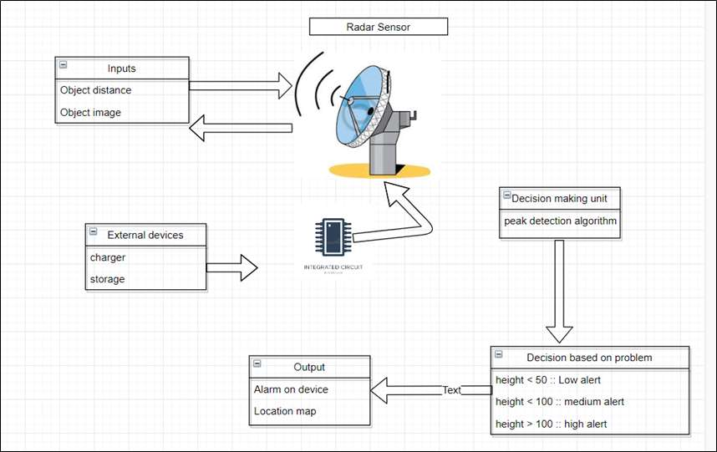

# Figure1:-System architecture

This architecture shows the working flow of the system. When the baby is on height then radar sensor takes the distance between the baby and the object .then decision making will take place. When the depth is below the height 50, then low alert will be given to the caretaker and when the height is greater than 50 then high alert will be provided to the caretaker for the alert purpose the display device like mobile, tablet etc.

**Methodologies:**

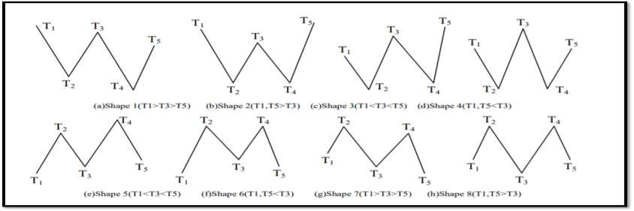

**Algorithm:**

Step 1: Divide signals curves {Xi } and collect maximum and minimum value into set {Ti}.

Step 2: Remove all coincident points in set {Ti}.

Step 3: Search in {Ti} to find shapes of class 1-5, and process all matched shapes until all shapes of class 1,2 are removed and all shapes of class 3,4,5 satisfy the following conditions: Dis(T1,T3)≥β and Dis(T2,T4)≥β and Dis(T3,T5)≥β

Step 4: After processing of the previous step, the rest maximum points of {Ti} are exactly target peak sand the rest minimum points of {Ti} are exactly target troughs. The results of calculating the distribution of number, height, distance of maximum/minimum points are the requested number, height and width of peaks/troughs of target signals

**FUTURE SCOPE AND CONCLUSION**

For implementing the IOT devices which ensures the complete solution for baby safety problems. A new idea to implement an automatic system for baby monitoring to remove the anxiety of the parents. This project proposes Smart IOT Devices for child safety and tracking helps the guardian/parents to locate and monitor the baby. If any abnormal values are read by the sensors then an SMS is sent to the guardian/parents mobile.